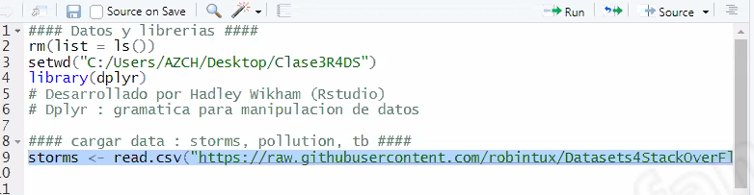
https://github.com/robintux/Datasets4StackOverFlowQuestions
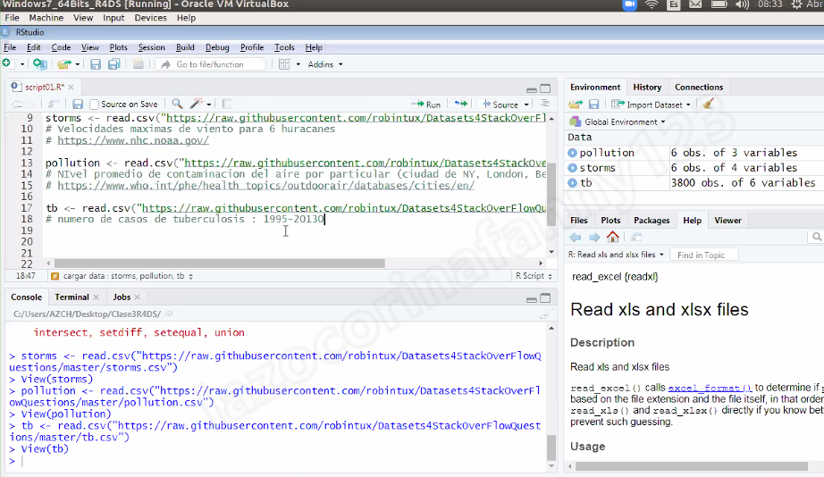
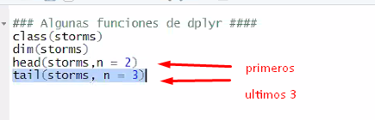
base de datos en plana

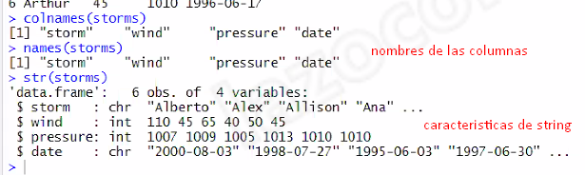
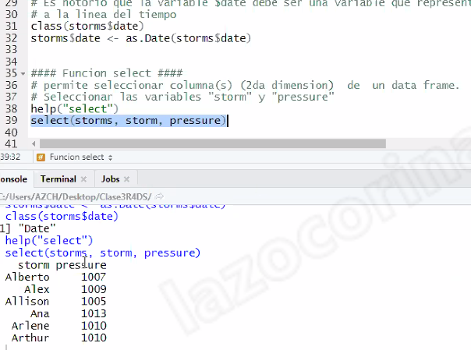
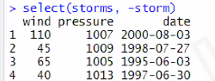
seleccionardata frase

cosas
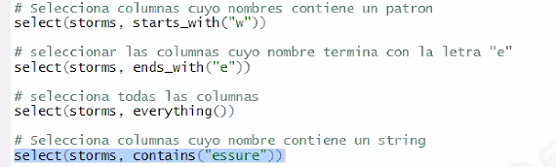
https://github.com/azchr4ds/Clase3R4DS.git
https://ggplot2.tidyverse.org/reference/theme.html
https://www.datanovia.com/en/blog/line-types-in-r-the-ultimate-guide-for-r-base-plot-and-ggplot/
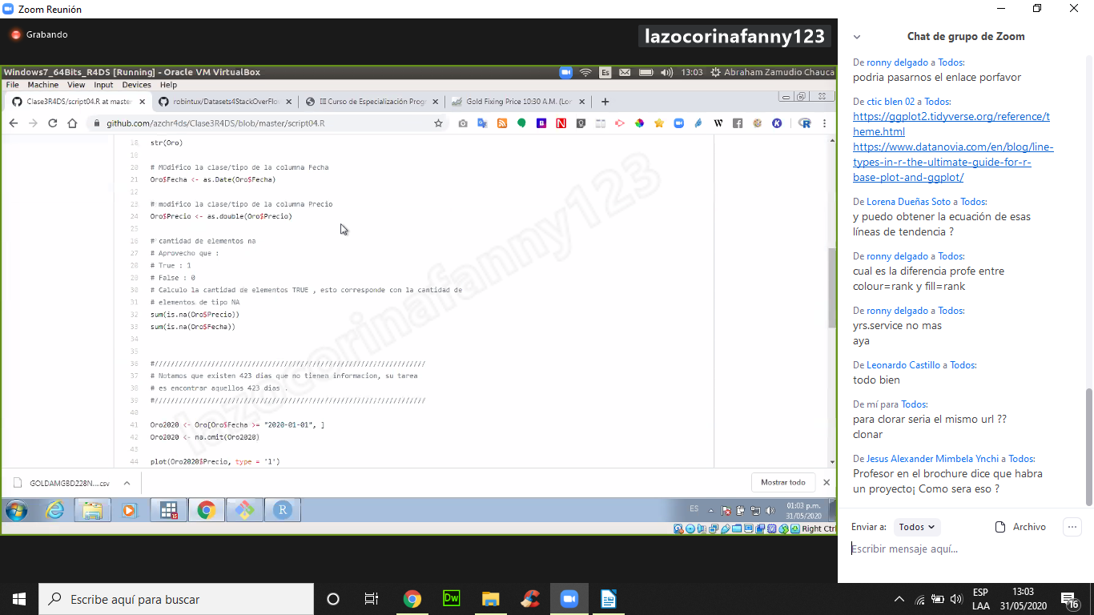
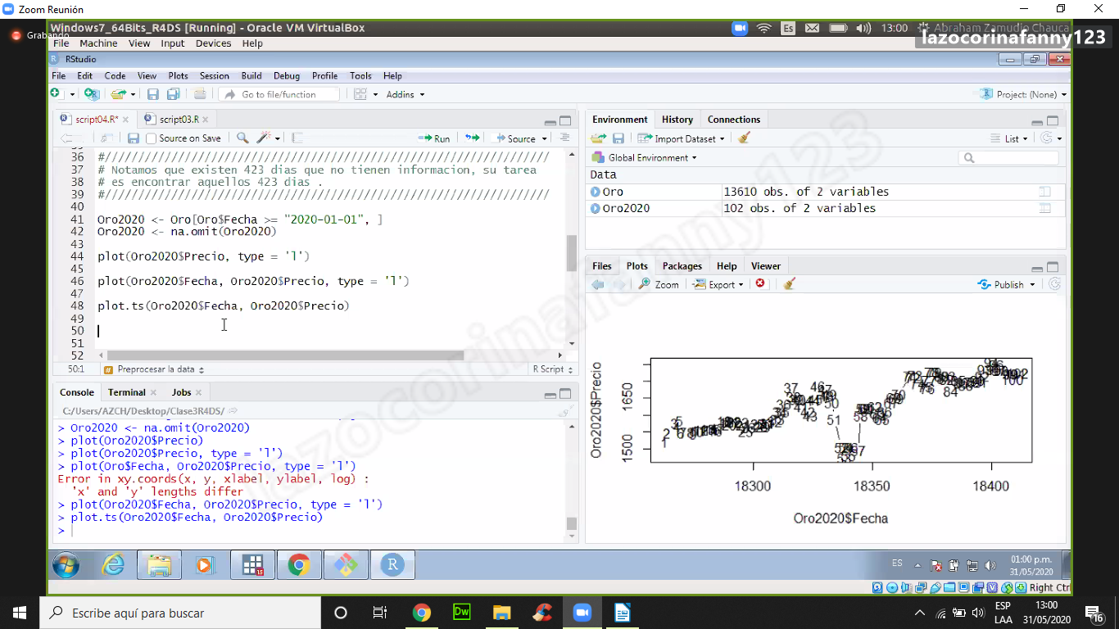
https://github.com/azchr4ds/Clase3R4DS.git

